NHS Lung Cancer Screening for residents in Sale Central – April/May 2026
Local information
Lung Cancer Screening will be offered to eligible people in Sale starting from 13 April 2026.
The NHS will be rolling out Lung Cancer Screening to people who are current or former smokers, aged 55-74 and based at the following group of GP practices:
Sale Central Primary Care Network – From approximately 13 April 2026
- Boundary House Medical Centre M33 2RH
- Washway Road Medical Centre M33 7SS
- Bodmin Road Health Centre M33 5JH
- Firsway Health Centre M33 4BR
- Conway Road Medical Practice M33 2TB

The appointments will take place on a mobile clinic, based at either Planet Ice on Oakfield Road, Altrincham, WA15 8EW or Old Trafford Cricket Ground, Entrance 1 Talbot Road, Manchester M16 0PX. (Patients will be told which in their postal invitation).

NHS Lung Cancer Screening is currently being rolled out across Greater Manchester, based on where it is needed most over the next few months and years. It is organised one Primary Care Network (group of GP surgeries) at a time. It has already been to Partington, Urmston and Altrincham and is now coming the other parts of Trafford. In the meantime, if people have any concerning symptoms, they should speak to their GP, who will be able to refer you for tests if needed. You can read about symptoms of lung cancer here: https://www.nhs.uk/conditions/lung-cancer/symptoms/

FAQs about NHS Lung Cancer Screening
WATCH A STORT VIDEO ABOUT LUNG CANCER SCREENING
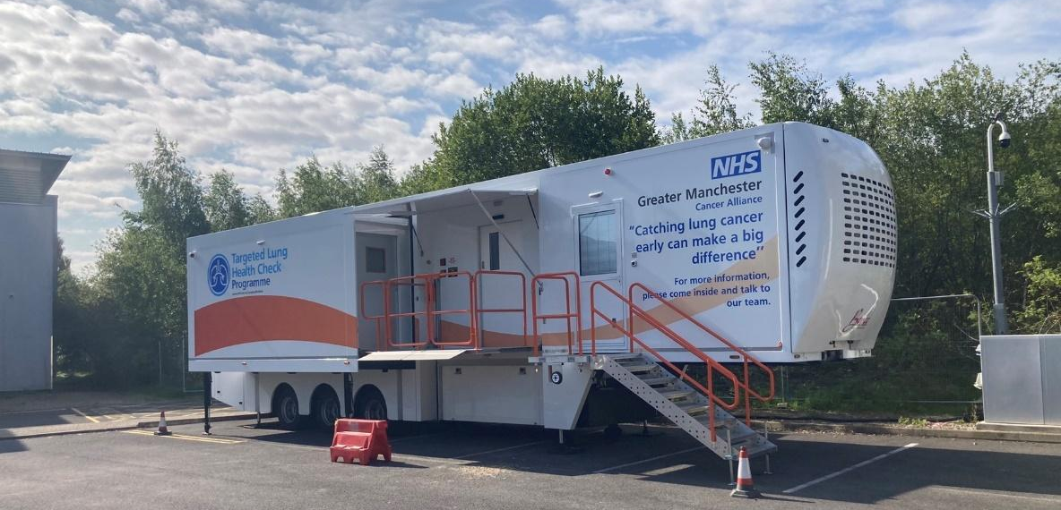
Q. How can my VCFSE group help spread the word about NHS Lung Cancer Screening?
A. Please see details of our posters, social media posts and news story below. We’d love you to share these in your communities.
Q. What is the aim of the NHS Lung Cancer Screening programme?
A. The aim of the programme is to detect lung cancer and disease early, so that people can be treated sooner and more effectively – saving more lives. Lung cancer often has no symptoms in the earlier stages which can result in it not being found until the later stages, when outcomes are less favourable.
Q. What is a Lung Health Check?
A. The lung health check takes part in two stages. The first is an appointment with a specially trained nurse to assess your risk level. If you are found to be at high risk of having lung cancer, you will be eligible for a low dose CT scan so we can capture an image of your lungs and identify if there are any issues which need further investigation or treatment.
Q. Where will lung health checks take place?
A. The lung health check appointment and CT scan will take place in a mobile unit. The mobile units will be parked in community venues or supermarket car parks, which have good transport links for ease of access.
Q. Who is eligible?
A. People aged 55 to 74 years old, who are current or former smokers, are eligible to participate in the programme.
Q. How will people be invited to the programme?
A. People will be invited to the programme based on the GP practice where they are registered. Everybody in the age range will be invited but only current or former smokers will be eligible for an appointment.
Q. I’m not eligible for the programme but concerned about my health, what should I do?
A. This is a targeted screening programme and people between 55 – 74 and who have smoked more than 100 cigarettes in their lifetime are eligible. If you are worried about any of the below symptoms, please see your GP as soon as possible:
  - a persistent cough or change in your normal cough
  - coughing up blood
  - Being short of breath
  - Unexplained tiredness or weight loss
  - An ache or pain when breathing or coughing
  - Appetite loss

Q. How can VCSFE organisations support this programme of work in their local community?
As this is a new service, many people may not be aware of its benefits. Detecting lung cancer early can make all the difference and this programme has demonstrated that it is effective at diagnosing lung cancers at a much earlier stage.
Please:
- Put up posters
- Share our social media messages or news story on your channels (see below)
- Get in touch with Jo Allsop about potential community engagement events.
Hi, I’m Jo Allsop, Community Engagement Facilitator for the Lung Health Check Programme. I work with the Lung Health Check providers, Manchester Foundation Trust, to support community outreach.
I can visit the local area with props (like some inflatable lungs), a stand and leaflets and provide information about NHS Lung Cancer Screening. I can also help facilitate with posters and leaflets about the service for your area. Please let us know of any good venues in your area or to suggest any good events we could attend.
Email joanne.allsop@mft.nhs.uk with suggestions for venues for visits.

Photos from Community Engagement Events

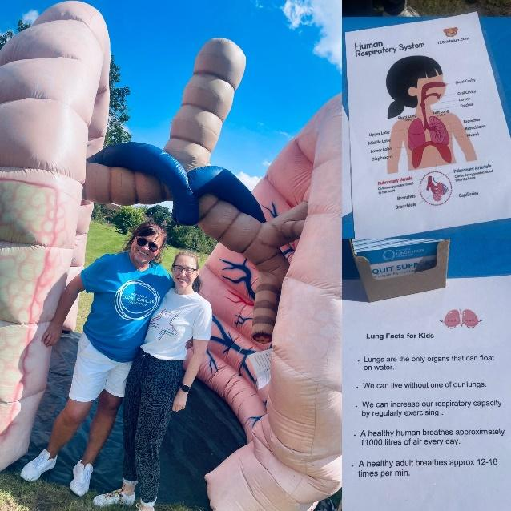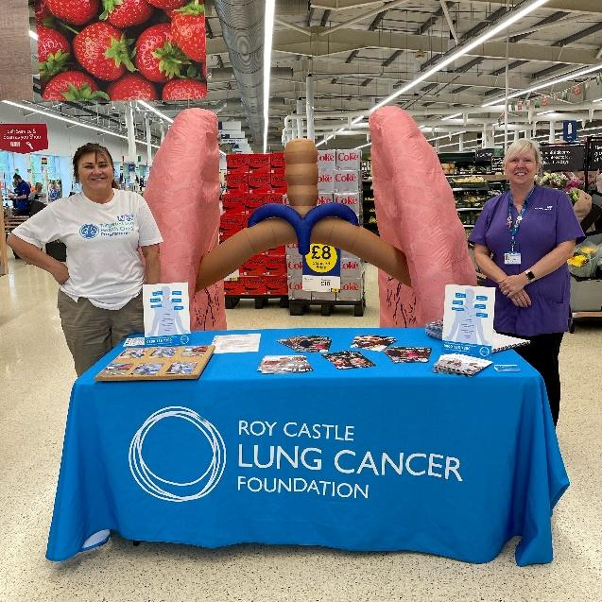
Posters, leaflets and postcards
We have an array of A4 posters and A5 flyers which we’d like you to help us display in community centres, libraries, places of worship, local businesses (either print out or hard copies posted).
Available in: English, Bengali, Polish, Urdu, Punjabi, Arabic and Romanian – please contact the Communications Team at Greater Manchester Cancer Alliance, gmcancer.comms@nhs.net if you need to enquire about other languages or to request posters to be posted out to your organisation. Please include the number of hard copies you would like and address where these should be posted to.

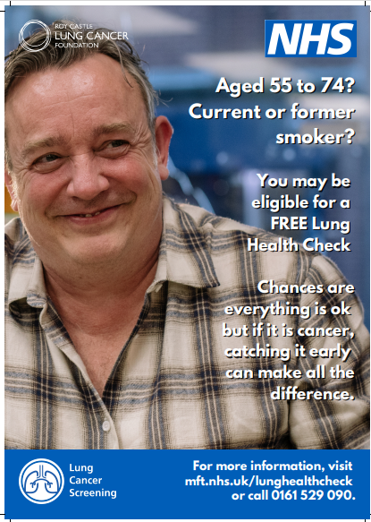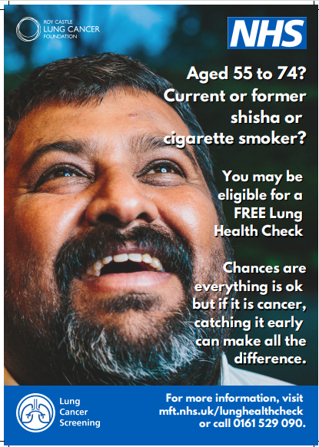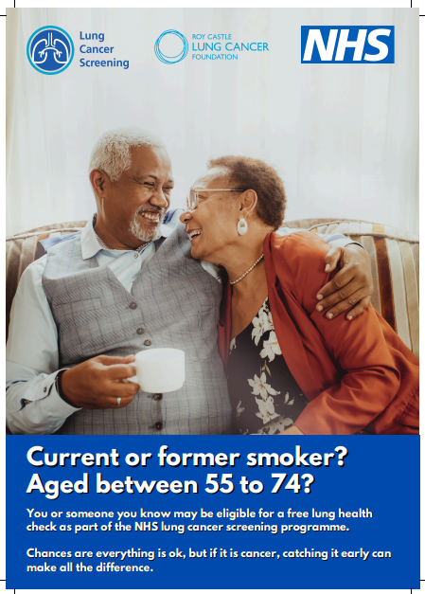

Social Media Assets
Please download assets here and find words here. You can use these to promote the campaign, on any Facebook, Instagram, Whatsapp or Twitter/X channels.

X/Twitter
NHS Lung Cancer Screening for people in #Sale
The NHS is offering free lung cancer screening for anyone who’s ever smoked aged 55-74 & registered with a GP in #Sale
Look out for an invite by post /text
See mft.nhs.uk/lunghealthcheck
#GMLungHealthCheck
Facebook / Instagram:
The NHS is offering free lung health checks to smokers and ex-smokers aged 55-74 who are registered with a GP in #Sale
The free checks are available to people aged 55-74 who are past and current smokers registered with a GP based at the following practices:
- Boundary House Medical Centre M33 2RH
- Washway Road Medical Centre M33 7SS
- Bodmin Road Health Centre M33 5JH
- Firsway Health Centre M33 4BR
- Conway Road Medical Practice M33 2TB
Look out for an invite in the post or via text message.
The checks are quick, free and they could ultimately save your life by finding lung cancer at an early stage, before you may have symptoms.
Most visitors to the lung health checks will get reassurance that everything is OK.
People who are invited for a lung health check will firstly talk to specialist nurse where you will answer some health and lifestyle questions, which will determine whether you are ‘high’ or ‘low’ risk. If you are deemed high risk, you will then be offered a low-dose computed tomography (CT) scan of your lungs, on the same day, on board the truck. This is to identify if there are any changes to your lungs which need further investigation or treatment.
If you have already received your invitation but missed your appointment, please contact the bookings team on 0161 529 0900.
For more information, please visit: mft.nhs.uk/lunghealthcheck
#GMLungHealthCheck

Community messages
Use these short bullet points about NHS Lung Cancer Screening coming to the area, if you want to give out a message at churches or community meetings for instance.
- NHS Lung Cancer Screening is being rolled out across Greater Manchester.
- People who aged 55-74 who smoke or used to smoke will be offer a free NHS Lung Health Check.
- The checks will be offered to eligible people registered with a specific group of GP surgeries in Sale from mid April 2026. You’ll get an invitation in the post or by text message.
- The appointments will take place on a mobile clinic, which will be based at a community location, with details given in your invitation.
- It’s really important that you attend even if you don’t have any symptoms.
- It’s open Monday to Saturday 8am until 8pm.
- You can re-book for a different day or time if you prefer. They have a lift and can offer adjustments to help you access the service if you need these, such as a quieter time, a longer appointment or a translator.
- At the check you’ll firstly talk to a specialist nurse where you will answer some health and lifestyle questions. This will determine whether you are ‘high’ or ‘low’ risk. If you are deemed high risk, you will be offered a low-dose computed tomography (CT) scan of your lungs on the same day.
- Not everyone will need a scan.
- If you do get a scan, you can wear your clothes for it and it only takes a few minutes. You will lie on a bed that moves through the scanner. The scanner is like a giant donut.
- The NHS will contact you with your results a few weeks afterwards.
- If you need any more tests the NHS will then arrange these for you.
- The Lung Health Checks are currently being offered to smokers and former smokers aged 55-74 at the following GP surgeries, in the Sale Central Primary Care Network (which began on 13 April):
- Boundary House Medical Centre M33 2RH
- Washway Road Medical Centre M33 7SS
- Bodmin Road Health Centre M33 5JH
- Firsway Health Centre M33 4BR
- Conway Road Medical Practice M33 2TB

- The checks have already been to most other parts of Trafford and Greater Manchester.
- If you are not eligible for a check but have any symptoms you are concerned about, you should speak to your GP who will be able to refer you for tests if needed. You can read about symptoms of lung cancer on the NHS website: https://www.nhs.uk/conditions/lung-cancer/symptoms/
- The checks currently stop at 74 due to national guidelines. If you are over 74 and have symptoms that you are worried about, please speak to your GP.

